# Technical specification

## Main Functions

1. Simulating the engine sound of motorcycle which includes the engine start, different throttle speeds and turning-off.
2. Engine sound replaceable. Users can replace the engine sound by App.
3. Up to four engine sounds installed. User can select the installed sound by App.
4. Effect can be set by App such as the volume and the throttle curve level.
5. The firmware can be updated by App to optimize the product.

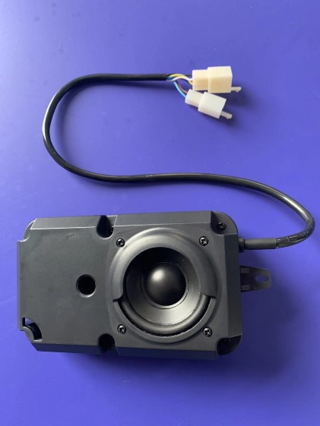 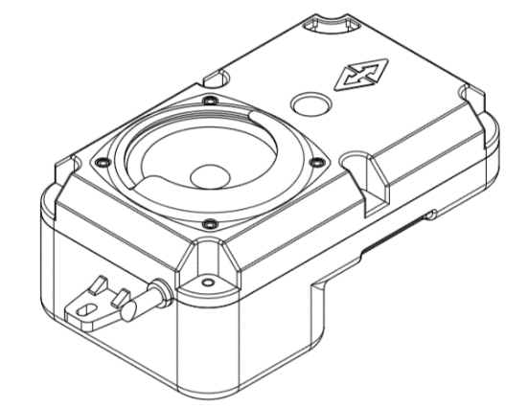

## Product Specification

###### Supply voltage

Voltage range:5V-18V

###### Speaker

Speaker Impedance: 4Ohms

Speaker Power ratings: 8W

Speaker Max power: 12W

ESS-EV supports up to 18V and 30W power output.

###### Amplifier

Audio Power amplifier Output under 4 Ohms: 20W/12V

Audio Power amplifier MAX output: 30W/18V

###### App Interface

Bluetooth BLE 4.0

Max Tx power: 0dbm

transmission distance: 10M

Users can configurate the EssEv, install the engine sound and update the firmware by app in the mobile phone. The App exchange data to EssEv through BLE 4.0.

###### Protect

Output is Short Circuit Overload and Thermally Protected

###### Size

182mm* 90mm* 66mm

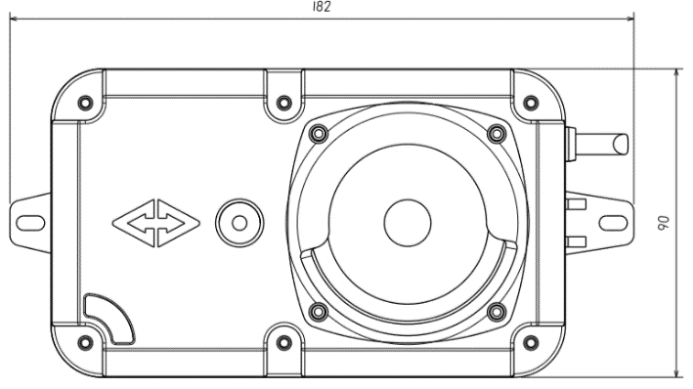

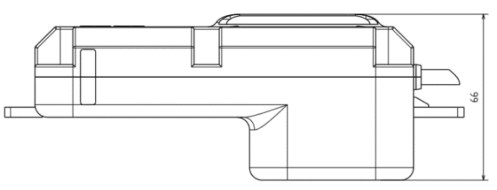

Cable length: 400mm

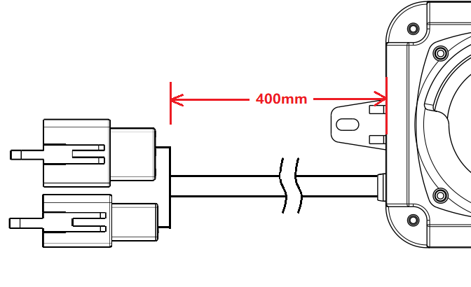

###### Mounting：

Method 1：

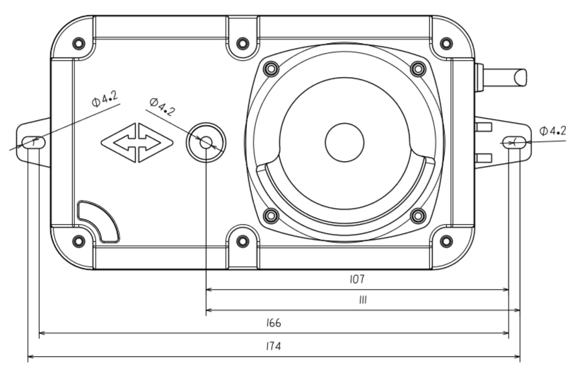

Method 2：

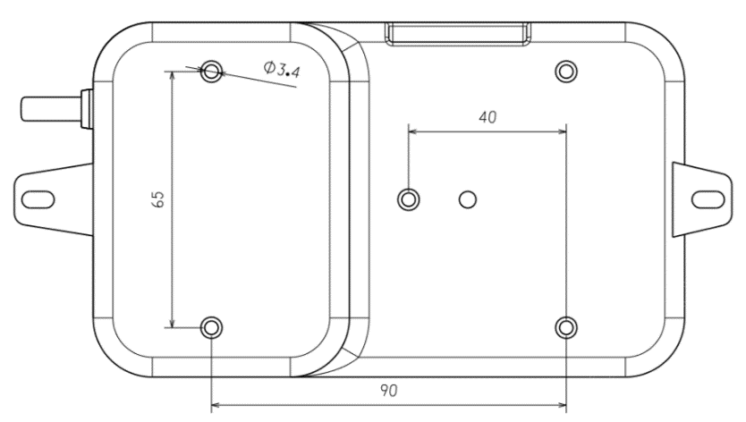

###### Current consumption

Quiescent current (keep the sound silence): less than 80mA

## Interface

###### Interface A

Interface A contains 2 pins.

Model：DJ7021A-2.8-11

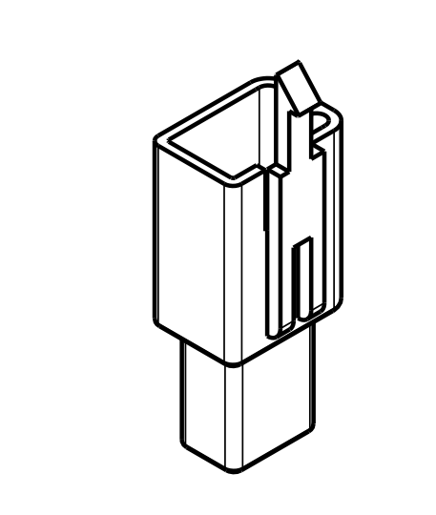

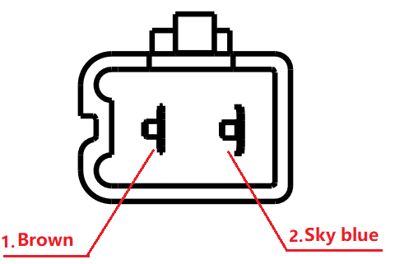 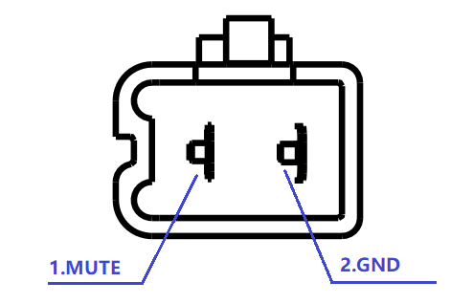

This is a button connector.

Pin 1: button pin. This button is for adjusting the volume, switching the engine sound and calibrating the HALL sensor.

Pin 2: GND.

###### Interface B

Interface B contains 5 pins.

Model：DJ7061A-2.8-11

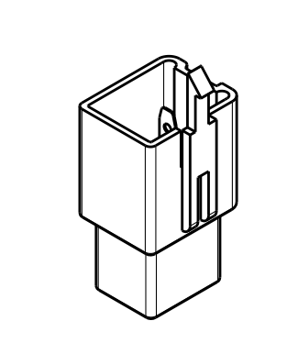

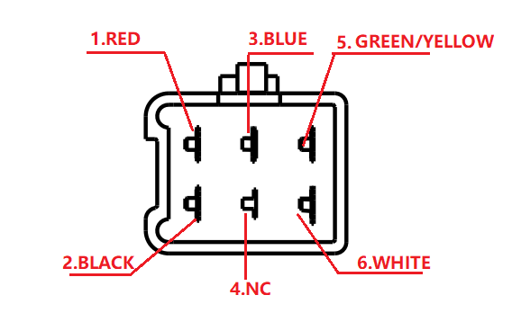 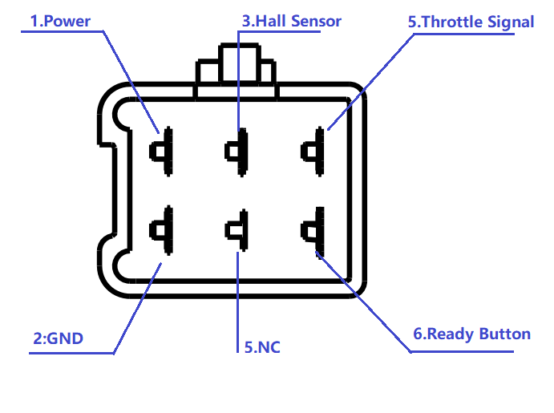

Pin1: Power. The operate voltage of this pin is 5V-18V.

Pin2: GND.

Pin3: HALL sensor. This pin gets the motorcycle real-time speed in the running mode. The operate voltage of this pin is 0-5V.

Pin4: NC

Pin5: Throttle turn pin. This pin gets the throttle turn voltage in the ready mode. The operate voltage of this pin is 0-5V.

Pin6: Ready pin. The operate voltage of this pin is 0-5v.

When the voltage on the pin is 5V, the motorcycle and the EssEv is in the ready mode. In this mode the sound follows the throttle turn and the engine response will be very fast.

When the voltage on the pin is 0V, the motorcycle and the EssEv is in the running mode. In this mode the sound follows the motorcycle running speed (Hall sensor). The engine speed sound and the motorcycle running speed correspond exactly.

## Adapter cable

The motorcycle signal adapter cable. It is no need to modify the wire and connector when mounting the EssEv on the SOCO motorcycle through this adapter cable.

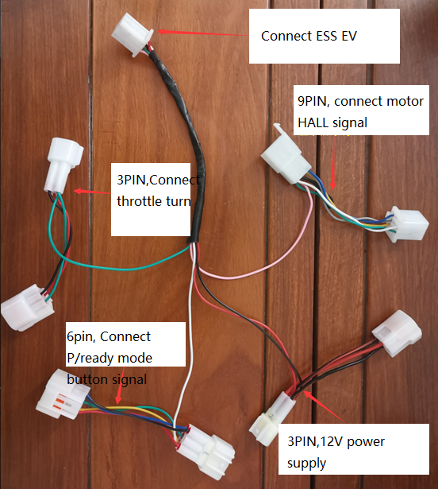

## Motorcycle engine sound simulation

The ESS EV engine sound simulator support two mode to simulate the motorcycle engine sound: the turn mode and the speed mode.

When the motorcycle is in P gear, the ESS EV enter the turn mode. The engine sound will change following the rotation of the turn.

When the motorcycle is in ready mode, the ESS EV enter the speed mode. The engine sound will change following the actual speed of the wheel.

## Volume level adjustment

When the ESS EV is working, click the button to adjust the volume level. The volume will decrease cycle. When the volume is mute, the volume will be max after clicking the button once.

## Engine sound switch

When the ESS EV is working. Long press the button can switch the engine sound. After switching, there will be beep sounds to mention which sound is selected.

## HALL calibration

For different electric motorcycles, there is a different correspondence between the speed of the vehicle and the number of HALL signals. The ESS EV has a HALL calibration mode that is used to easily match the engine sound to the motorcycles.

The HALL calibration process is as follows:

1. Connect the ESS EV to the motorcycle.
2. Frame the rear wheel of the electric motorcycle.
3. Hold the button the ESS EV, and power on the electric motorcycle.
4. There will be a long beep mention the ESS EV enter
5. the calibration mode.
6. Switch the motorcycle to “ready” mode and rotate the turn. The wheel will reach the maximum rotation speed.
7. Long press the button. The ESS EV will long beep for 1 second which mention the calibration is successful. Then the ESS EV will enter the working mode and making the engine sound.

If there are three short beeps after you long pressing the button, it is mention that the calibration is failed. After the failed calibration, the ESS EV will enter the working mode. If you want to recalibration, you should long press the button and power the motorcycle again.